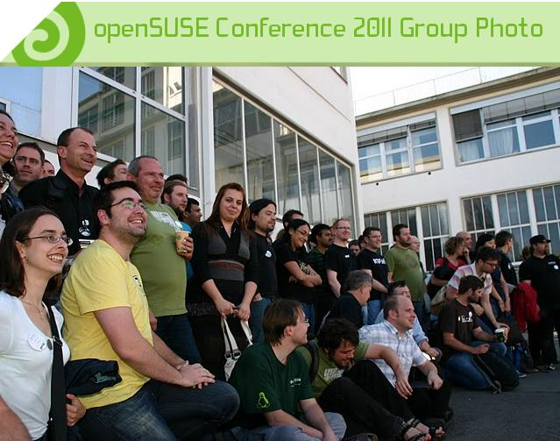
About openSUSE
The openSUSE project is a worldwide effort promoting the use of Linux everywhere. openSUSE creates one of the world's best Linux distributions, working together in an open, transparent and friendly manner as part of the worldwide Free and Open Source Software community.

The project is controlled by its community and relies on the contributions of individuals, working as testers, writers, translators, usability experts, artists, ambassadors and developers. The project embraces a wide variety of technology, people with different levels of expertise, speaking different languages and having different cultural backgrounds.

Have a lot of fun...

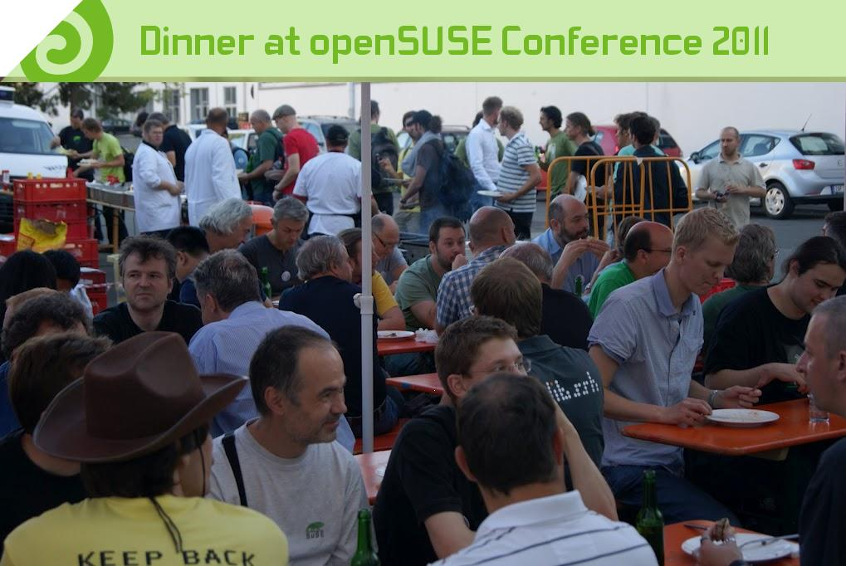
The openSUSE Conference 2012

Now in its fourth year, the openSUSE Conference has become one of the most dynamic and collaborative events in the Free and Open Source Software world. Bringing together openSUSE contributors and members of numerous other Open Source projects, both upstream projects like LibreOffice, Samba and GNOME as well as from other distributions like Fedora and Debian, this conference provides a rich environment for innovation.

Topics for the openSUSE Conference range from technical talks about packaging, Open Build Service and development tools to more community-oriented discussions about the future and direction of open source software. With more than a 30% increase in attendees over 2010, last year's conference was a resounding success, and this year promises to be even better.

Like last year, the openSUSE conference will be combined with the SUSE Labs engineering meeting. SUSE Labs is a team within SUSE focusing on core development including kernel, tool chain and samba as well as research and working tightly with developer communities around relevant projects. SUSE Labs also forms the ultimate line of support for customer issues and will bring a number of deeply technical sessions to the openSUSE conference as well as lead a number of discussions about future directions of core Linux projects.

Place and Date
The openSUSE Conference 2012 will take place in Prague. Location and date are still to be determined.

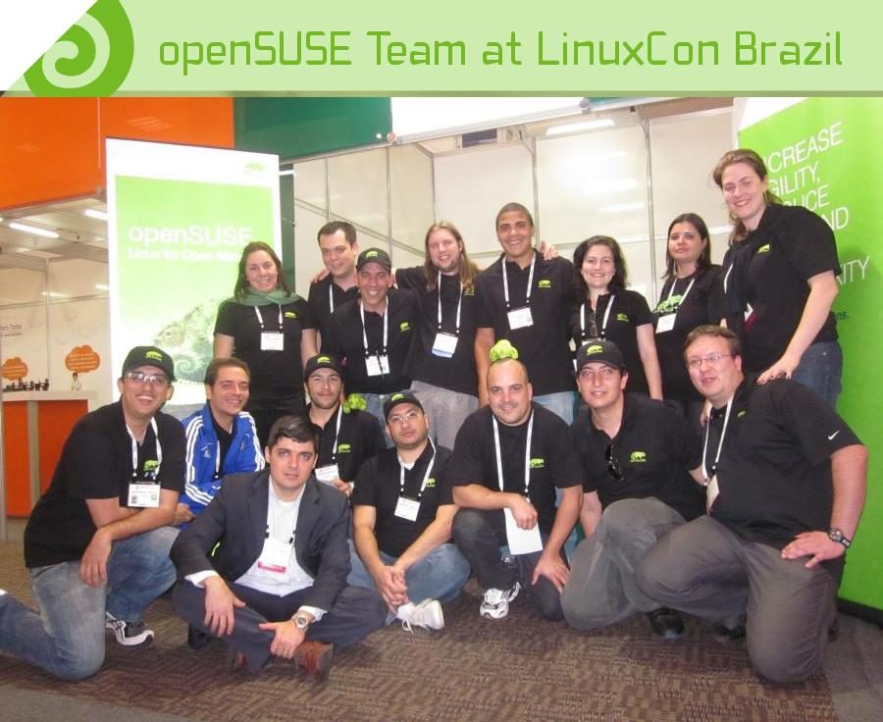
Conference Admission
Based on earlier years attendance numbers we expect to welcome about 500 Open Source developers, testers, usability experts, artists and professional attendees. Admission to the openSUSE conference is free. However a professional attendee ticket is available that offers some additional benefits.

Professional pass gives you access to:
- All openSUSE sessions
- Networking session/speaker dinner
- Feedback session with SUSE executive management team
Cost: U.S. $350 or €250

Community pass
Is free and gives you access to all openSUSE sessions

Sponsorship Investment
By sponsoring this prominent event, you will gain excellent industry visibility, attract active community members to your organization and its work, and proudly support the open source community. Your sponsorship will be used to defray travel costs for speakers and attendees as well as facilities costs.
The following main sponsorship options are available:

GOLD
  - Can present up to two sessions*
  - Receive up to 15 total Professional entry tickets
  - Highlighted as Gold Sponsor on conference T-shirt
  - Logo appears in all Birds of a Feather (BOF) rooms
  - Receive all Silver sponsorship benefits
  - Becomes Silver Sponsor of the openSUSE community for 2013
Investment: U.S. $ 10,000 or € 7,000

SILVER
  - Can present one session*
  - Receive up to 10 total Professional entry tickets
  - Sponsor introduction at oSC kickoff
  - Highlighted as Silver Sponsor on conference T-shirt
  - Logo appears in main conference room
  - Receive all Bronze sponsorship benefits
  - Becomes Bronze sponsor of the openSUSE community for 2013
Investment: U.S. $ 5,000 or € 3500
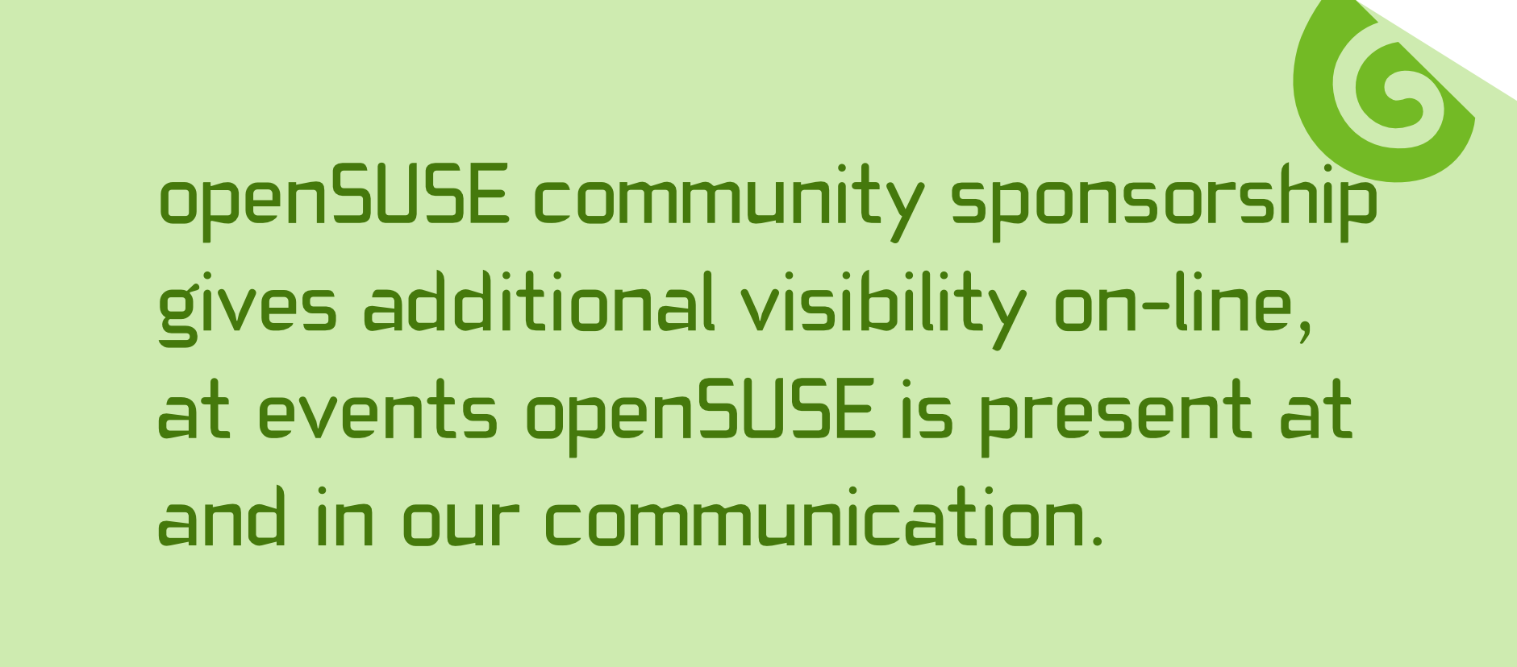

BRONZE
  - Up to 5 Professional entree tickets
  - Mention in all distributed materials
  - Company logo placement on banner in main hall
  - Recognition in the closing session
  - Ability to provide goodies in the conference bag (at sponsor's expense)
  - Opportunity for a joint press release with openSUSE/SUSE Labs conference
Investment: U.S. $ 2,500.00 or € 1750

SUPPORTER
  - Show your support for openSUSE and the openSUSE Conference!
  - Receive 2 Professional entree tickets
  - Logo appears on the sponsorship page
Investment: U.S. $ 1000.00 or €700

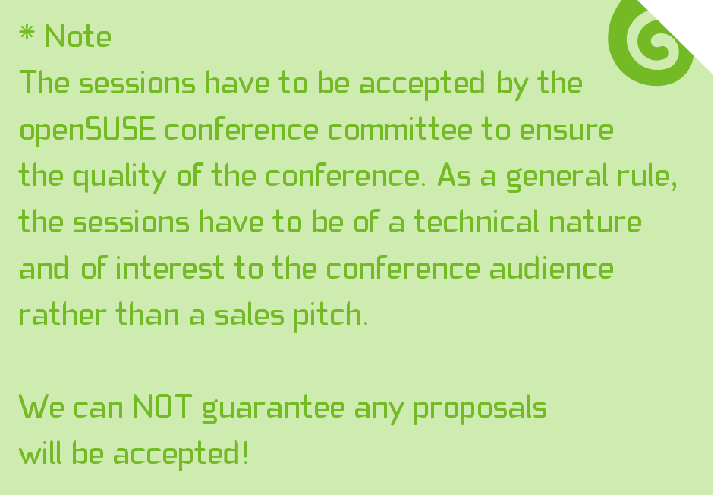

Partners
Besides the general sponsorships, we are offering a few partnership options to allow you to bring our community some fun items, including ice cream, coffee and lunches. If you sponsor any of these, your logo and name will be connected to the services and of course your logo will be part of the partner section of our promotional materials.
A partnership package can be taken separate or in combination with a main sponsorship package, in which case we give a discount on the partnership costs. An option "with sponsorship" shows the additional costs on top of the main sponsorship. The "without sponsorship" is the price for a partnership without a Bronze, Silver or Gold sponsorship.

BLACK GOLD PARTNERSHIP
The Black Gold Partnership allows the partner to supply a set number of free coffee/tea tickets to the attendees of the conference each day. Depending on the number of tickets per attendee and other sponsorship options, the costs range from $2,000 to $7,000.

tickets | Without sponsorship | With sponsorship
2 | $2500 (€1750) | $2000 (€1400)
4 | $5000 (€3500) | $4000 (€2800)
8 | $7000 (€4900) | $6000 (€4200)

HIGH NOON REFRESH PARTNER
This partnership is for companies wishing to have their brands highlighted by providing daily lunch tickets to the attendees.

Without sponsorship | With sponsorship
$5000 (€3500) | $4000 (€2800)

KICK BACK PARTNERSHIP
It's party time! This partnership is for any company which aims to support the 'Lizard Lounge' party organized for the attendees of the conference. The company's brand will be prominently displayed at the party location.

Without sponsorship | With sponsorship
$6000 (€4200) | $5000 (€3500)

BRAIN FREEZE PARTNERSHIP
This partnership gives your company the possibility to inspire our attendees with some fresh ice cream tickets.

tickets | Without sponsorship | With sponsorship
1 | $2500 (€1750) | $2000 (€1400)
2 | $5.000 (€3500) | $4000 (€2800)

All partners will be recognized
in the closing session.

For questions please contact:
Izabel Cerqueira Valverde
Sponsorship manager
openSUSE Conference Organization
e-mail izabelvalverde@opensuse.org
phone +55 118 510 4280

We appreciate your attention and hope to have you with us!

Images courtesy of Pascal Bleser; Brochure Artwork: Kamila Součková.

